Heat Wave-THIS WORKS
July 25th, 2022

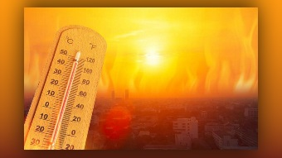
And this is very important.

I want to share with you -you do not have to die in this heat. I am extremely prone to heat stroke and heat rash and have lived in the Sonoran Desert for many years, and there is an easy way to take care of it. If you have water, you will be cool, and here is how:

Get a thin square or rectangular cotton fabric- like a muslin dish towel, not a heavy one with the pile on it, but a thin one, soak it in water and put it over your head, let the water drip down on your shoulders. It is good to wear a hat as well but wet your hat down. And you have got to repeat this every thirty minutes or so, you do not always have to let it drip on you, you can put it over your shoulders and allow it to keep your back, your neck and your chest damp, and I promise you, you will be living in air conditioned paradise for about thirty minutes.

So, or if you are very brave, soak your shirt and put it on wet and keep soaking it- Take it off, soak it, put it back on. What I did with my big, heavy gray habit in Phoenix was I would get into the shower with it on, and I would get soaked down and wring the water out and come out of the shower and I was good to go for at least an hour and a half. Of course, it was messy, but it really worked.

So, you do not have to suffer in this heat, all you have to do is keep water on your body and allow that evaporation to cool you down. Ok.

God bless you, dear family, please take care, use good common sense when dealing in this heat.

